DOCUMENT 08 — Backend Services & API Contracts
Visionary Internal · v1.0 · Public + internal contracts over the AIRA service set

Thin, versioned, role-scoped APIs. The gateway enforces auth + access boundaries;
services are stateless except their own stores. MVP ships 5 services (VATS §8.3);
the rest land per sprint without breaking contracts.

1. Request flow
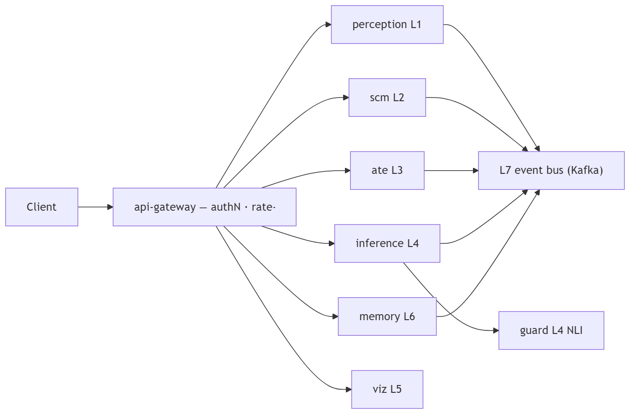

2. Core contracts (v1)

Endpoint | Method | Role | Returns
/v1/auth/otp · /v1/session | POST/GET | all | token, role claims
/v1/home/{role} | GET | all | decision-Home view-model (next action + reason + evidence refs)
/v1/syllabus/{board}/{class}/{subject} | GET | all | chapters/topics/concepts OR provisional:true
/v1/learn/{concept} | GET | student/teacher | lesson packet + [SCENE:…] tokens
/v1/ask | POST (stream) | all | streamed explanation + check-question
/v1/practice/next · /v1/practice/answer | GET/POST | student/pro | adaptive question · verdict + SCM delta
/v1/build/artifacts | CRUD | all | portfolio artifacts
/v1/class/{id}/aggregate | GET | teacher/org | heatmap (aggregate only, refresh ≤15min)
/v1/child/{id}/report | GET | parent (consent-scoped) | weekly summary
/v1/memory · /v1/memory/{id} | GET/DELETE | owner | memory rows + erasure

3. Rules
- Access enforced server-side: student=own · teacher=cohort aggregate · parent=connected child · org=aggregate-only (never individual private data).
- Error contract {code, retryable, user_message}; never leak internals; missing syllabus returns 200 + provisional:true, never 404 to a child.
- All mutating calls idempotent; streaming via SSE/WebSocket with cancel; math via calculate_math tool, never LLM arithmetic (AIRA DDR-06).

OKF
KF1 p95 gateway→first-token ≤200ms · KF2 zero cross-role leaks in contract tests · KF3 100% of calls emit L7 event · KF4 versioned, backward-compatible 12 months · KF5 provisional path never blocks a user.

